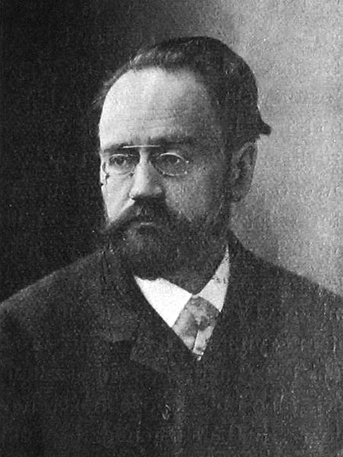**Zola, Emile (1840-1902)**

Emile Zola was a key figure in French realism and a leading figure of the naturalist movement. A prolific novelist, journalist, and theorist, he is best known for his reflections on contemporary French society in the ambitious twenty-novel *Les Rougon-Macquart* cycle, a series focused on the fortunes of one family over several generations. Zola sought to express new scientific ideas about heredity and environmental factors in the development of human behaviour, as well as to use his fictional family to represent the paradoxical nature of a corrupt yet dynamic society, emerging out of the Second Empire. Over more than twenty years, Zola’s novel cycle examined nineteenth-century French society through social, political and artistic lenses, causing controversy within the literary establishment for his representations of the working class, changing morality and sexuality at the end of the century, and the emerging concerns of modernity. These themes were also more broadly expressed in Zola’s thirty-one novels, five short story collections, diverse literary criticism, several plays, and a long journalistic career. His political writings culminated in Zola penning the infamous ‘J’Accuse…!’ open letter regarding the Dreyfus Affair to the President of France, as the final move in his campaign on behalf of Captain Alfred Dreyfus, a Jewish officer who was wrongly convicted of communicating French military secrets to Germany in 1894.

Portrait of Emile Zola (Wikimedia Commons): <https://commons.wikimedia.org/wiki/%C3%89mile_Zola#/media/File:Emil_Zola.jpg>

Born in Paris in 1840 to an engineer and the daughter of a glazier, Zola spent most of his childhood in Aix-en-Provence against a background of political upheaval: the dissolution of the Second Republic, and the start of the Second Empire under Napoleon III, would provide Zola with the setting and inspiration for the *Rougon-Macquart* novels. Zola and his mother moved to Paris in 1858, and several years of illness and hardship followed. He began his literary career as a shipping clerk in 1862 at Hachette, a well-known publishing house, before being quickly promoted to head of publicity. Zola began work as a fully-fledged journalist in 1863, and published his first work of fiction in the form of *Contes à Ninon* in 1864*,* a collection of short stories that demonstrate the beginnings of Zola’s naturalist style but also an interest in fairytale forms and Swiftian satire. Zola’s early gift for evocative, artistic social commentary was more fully realised in the novels that followed, and the positive reception of Zola’s fourth novel*, Thérèse Raquin* (1867), established him as a leading figure of the naturalist movement.

While primarily known today for his fiction, Zola was also a noted literary critic and wrote several pieces critiquing the Parisian art establishment and supporting the rise of Impressionism. In the 1870s this interest in journalism was turned towards the Franco-Prussian War, at which time Zola became a political reporter; it was also at this time that he published the first novel in the *Rougon-Macquart* cycle, *La Fortune des Rougon* (1871)*.* The series of novels continued for more than twenty years. Zola saw himself as experimenting with the form of the novel, and his fiction shows a writer negotiating the role of the political, journalistic observer, balancing ideological symbolism with the demands of realism. Throughout his literary career Zola continued to work as a journalist, acting as foreign correspondent for a Russian newspaper, drama critic, and writing essays on naturalism.

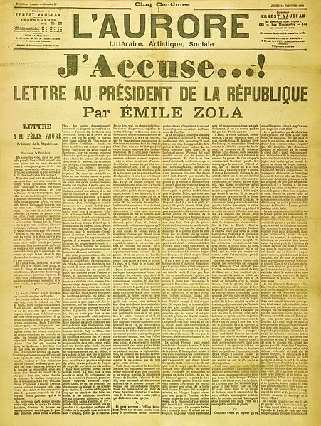 As his career progressed Zola’s work – as novelist, journalist and theorist – was met with increasing controversy, with his own ‘disciples’ denouncing his fiction as pornographic. At various moments, Zola openly criticised the artistic academy, the regime of Napoleon III and the beginnings of the Third Republic. His fiction critiqued contemporary society, depicting moral ambivalence and open sexuality: the naturalist school, for Zola, had to be defined in opposition to the literary expectations of the bourgeoisie, and as such his novels were met with sharp criticism. ‘J’Accuse…!’ and the Dreyfus Affair were the climax of a politically-motivated literary career, and saw Zola tried for libel following which, facing one year’s imprisonment, he went into exile in England. The letter, published on the front page of *L'Aurore* in 1898, charged those involved in the Dreyfus Affair with covering up proof of Captain Dreyfus's innocence. The piece represented an important intervention in contemporary debates about the role of the public intellectual, aligning writers, artists and scholars with justice and the true voice of the French Republic and its values in the face of state control and nationalism. When he died, Zola was working on *Vérité*, a fictionalised account of the Dreyfus Affair.

Front page of L'Aurore (Wikimedia Commons): <https://commons.wikimedia.org/wiki/File:J_accuse.jpg>

**List of Works (Selected)**

*Oeuvres complètes.* Edited by Henri Mitterand. (1967) Paris: Cercle du Livre Précieux.

Early Works

*Contes à Ninon* (1864)

*La Confession de Claude* (1865)

*La Voeu d’une morte* (1866)

*Les Mystères de Marseille* (1867)

*Thérèse Raquin* (1867)

*Madeleine Férat (1868)*

*Les Rougon-Macquart* Cycle

*La Fortune des Rougon* (1871)

*La Curée* (1873)

*La Ventre de Paris* (1873)

*La Conquête de Plassans* (1874)

*La Faute de l’abbé Mouret* (1875)

*Son Excellence Eugéne Rougon* (1876)

*L’Assommoir* (1877)

*Une page d’amour* (1878)

*Nana* (1880)

*Pot-Bouille* (1882)

*Au Bonheur des Dames* (1883)

*La Joie de vivre* (1884)

*Germinal* (1885)

*L’* *Œuvre* (1886)

*La Terre* (1887)

*Le Rêve* (1888)

*La Bête humaine* (1890)

*L’Argent* (1891)

*La Débâcle* (1892)

*Le Docteur Pascal* (1893)

*Les Trois Villes* Trilogy

*Lourdes* (1894)

*Rome* (1896)

*Paris* (1898)

*Les Quatre Evangiles* Series

*Fécondité* (1899)

*Travail* (1901)

*Vérité* (1903)

**References and Further Reading**

Baguley, David. (1976, 1982) *Bibliographie de la critique sur Emile Zola,* 2 vols. *1864-1970* and *1971-1980,* Toronto: University of Toronto Press. There is an annual update to this bibliography in *Les Cahiers naturalistes.*

Brown, Frederick. (1996) *Zola: A Life,* London: Macmillan.

Hemmings, F. W. J. (1977) *The Life and Times of Emile Zola,* New York: Scribners.

Knapp, Bettina. (1980) *Emile Zola,* New York: Frederick Ungar Publishing Co.

Nelson, Brian. (ed.) (2007) *The Cambridge Companion to Zola,* Cambridge: Cambridge University Press.

**Emily Bowles, University of York**